dextrose and entropy CPU usage report, march 1, 2019

(written by A. East, with data provided by J. Kraushaar)

entropy.lcd.uregina.ca
- a 2010 Ciaratech FUSION SMP supercomputer (shared memory)
- 72 CPU cores
- 144 GB RAM
dextrose.lcd.uregina.ca
- a 2010 Ciaratech supercomputer cluster (distributed memory)
- 420 CPU cores (12 per node: 33 VXPRO nodes + 2 TITAN graphics nodes)
- 24 GB RAM per node (2 GB per core; 840 GB total)

Page 2: Dextrose report, entire lifetime (2010-2018)
Page 3: Entropy report, only last 2 years (2017-2018)

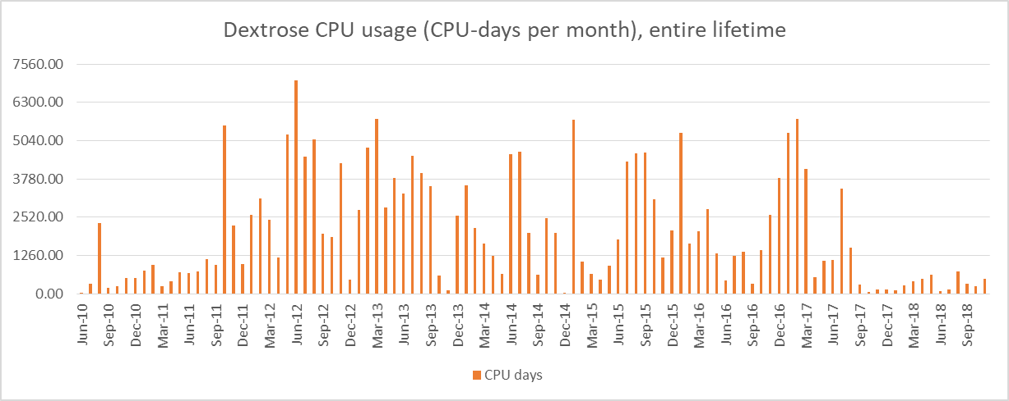

aravindn | Nikhil Poolakkal Aravindakshan | /home/dextrose/aravindn | On since Tue Feb 26 12 24 (CST) on pts/1 from a031382.chem.uregina.ca
rly508 | Ran Leng | /home/dextrose/rly508 | Last login Tue Feb 26 10 05 (CST) on pts/0 from 142.3.188.56
dhp885 | Darpan Patel | /home/dextrose/dhp885 | Last login Mon Feb 25 15 57 (CST) on pts/2 from a031388.chem.uregina.ca
east | Allan East | /home/dextrose/east | Last login Sun Feb 24 10 03 (CST) on pts/0 from ev17173.sci.uregina.ca
aam237 | Abdulrahman Mukadam | /home/dextrose/aam237 | Last login Fri Feb 15 15 55 (CST) on pts/3 from a031383.chem.uregina.ca
mihichuk | Lynn Mihichuk | /home/dextrose/mihichuk | Last login Fri Feb 15 08 25 (CST) on pts/0 from ev14043.chem.uregina.ca
dhillons | Shamneet Dhillon | /home/dextrose/dhillons | Last login Thu Jan 31 13 08 (CST) on pts/4 from cl122lab.cs.uregina.ca
kuntz99c | Colin Kuntz | /home/dextrose/kuntz99c | Last login Fri Jan 11 11 59 (CST) on pts/2 from a031384.chem.uregina.ca
aherman | Allen Herman | /home/dextrose/aherman | Last login Mon Jun 4 16 18 2018 (CST) on pts/0 from ev15139.mathstat.uregina.ca
hoffertl | Lucas Hoffert | /home/dextrose/hoffertl | Last login Fri Jul 29 15 29 2016 (CST) on pts/0 from a031383.chem.uregina.ca
sumon20k | Kazi Sumon, Prof. East's student | /home/dextrose/sumon20k | Last login Tue Feb 17 17 45 2015 (CST) on pts/1 from a031388.chem.uregina.ca
hilder | Robert Hilderman | /home/dextrose/hilder | Last login Thu Dec 18 13 07 2014 (CST) on pts/1 from entropy.lcd.uregina.ca
jtyao | JingTao Yao | /home/dextrose/jtyao | Last login Mon Sep 20 16 05 2010 (CST) on pts/10 from ev09352.csdyn.uregina.ca
butz | Cory Butz | /home/dextrose/butz | Last login Wed Jul 14 21 39 2010 (CST) on pts/0 from venus.cs.uregina.ca
gerhard | David Gerhard | /home/dextrose/gerhard | Never logged in.
bardenj | John Barden | /home/dextrose/bardenj | Never logged in.
park111b | Brett Park | /home/dextrose/park111b | Never logged in.
ubbens2j | Jordan Ubbens | /home/dextrose/ubbens2j | Never logged in.

zhang40q | Qingzhou Zhang | /home/dextrose/zhang40q | Last login Mon Feb 25 12 03 (CST) on pts/0 from zhang40q-1.stud.uregina.ca
east | Allan East | /home/dextrose/east | Last login Sun Feb 24 10 04 (CST) on pts/0 from ev17173.sci.uregina.ca
epp466 | Elham Parhizkar Abyaneh | /home/venus1/epp466 | Last login Mon Oct 15 08 14 (CST) on pts/0 from church.lcd.uregina.ca
hilder | Robert J. Hilderman | /home/venus/hilder | Last login Thu Sep 6 15 39 (CST) on pts/9 from hercules.cs.uregina.ca
zhang83y | Yan Zhang | /home/venus1/zhang83y | Last login Tue May 8 15 31 2018 (CST) on pts/4 from a058605.csdyn.uregina.ca
dhp885 | Darpan Patel | /home/dextrose/dhp885 | Last login Tue Jan 9 14 54 2018 (CST) on pts/0 from itcoordinator.sci.uregina.ca
fic866 | Ferdinand Ihringer | /home/dextrose/fic866 | Last login Tue Apr 4 17 10 2017 (CST) on pts/3 from 142.3.211.156
nikravam | Mohammad Hossein Nikravan | /home/zermelo/nikravam | Last login Tue Jan 24 13 13 2017 (CST) on pts/2 from 142.3.169.35
ubbens2j | Jordan Ubbens | /home/venus1/ubbens2j | Last login Tue Jul 26 09 51 2016 (CST) on pts/18 from 198.169.126.105
park111b | Brett Park | /home/venus1/park111b | Last login Tue Jun 21 13 19 2016 (CST) on pts/2 from 198.169.126.105
gerhard | David Gerhard | /home/venus/gerhard | Last login Wed Jun 1 15 33 2016 (CST) on pts/2 from 204.83.115.31
hepting | Daryl Hepting | /home/venus/hepting | Last login Tue May 31 11 41 2016 (CST) on pts/2 from 142.3.200.40
abbasiar | Reza Abbasian | /home/venus1/abbasiar | Never logged in.
almestae | Emad Almestadi | /home/venus1/almestae | Never logged in.
anima | Animation Research | /home/research/anima | Never logged in.
aravindn | Nikhil Poolakkal Aravindakshan | /home/dextrose/aravindn | Never logged in.
bardenj | John Barden | /home/dextrose/bardenj | Never logged in.
binamerh | Hadeel Hatim Bin Amer | /home/venus1/binamerh | Never logged in.
butz | Cory Butz | /home/venus/butz | Never logged in.
desouzjh | Jhonatan Oliveira | /home/venus1/desouzjh | Never logged in.
evarista | Andre dos Santos | /home/venus1/evarista | Never logged in.
fan225 | Gaojian Fan | /home/zermelo/fan225 | Never logged in.
hamilton | Howard Hamilton | /home/venus/hamilton | 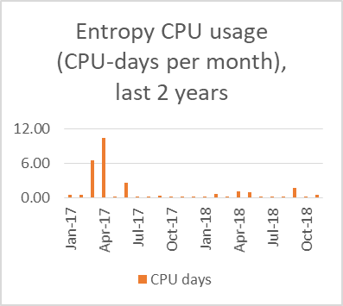  Never logged in.
hu263 | Hanlin Hu | /home/venus1/hu263 | Never logged in.
jahan20m | Moslema Jahan | /home/venus1/jahan20m | Never logged in.
jtyao | JingTao Yao | /home/venus/jtyao | Never logged in.
karim20m | Muhammad Rezaul Karim | /home/venus1/karim20m | Never logged in.
kuntz99c | Colin Kuntz | /home/dextrose/kuntz99c | Never logged in.
lelis | Levi Lelis | /home/zermelo/lelis | Never logged in.
manfredc | Cristina Manfredotti | /home/venus/manfredc | Never logged in.
mihichuk | Lynn Mihichuk | /home/dextrose/mihichuk | Never logged in.
moise20m | Marian Moise | /home/saturn/moise20m | Never logged in.
montaghv | Vajihollah Montaghami | /home/venus1/montaghv | Never logged in.
mtm916 | Matthew Mann | /home/dextrose/mtm916 | Never logged in.
sadaouis | Samira Sadaoui | /home/venus/sadaouis | Never logged in.
sadeqi2m | Mehdi Sadeqi | /home/venus1/sadeqi2m | Never logged in.
ugheoket | Thomas Ugheoke | /home/venus1/ugheoket | Never logged in.
yang | Xue-Dong Yang | /home/venus/yang | Never logged in.
yyao | Y. Yao | /home/venus/yyao | Never logged in.
zhao224y | Yang Zhao | /home/venus1/zhao224y | Never logged in.
zilles | Sandra Zilles | /home/venus/zilles | Never logged in.

